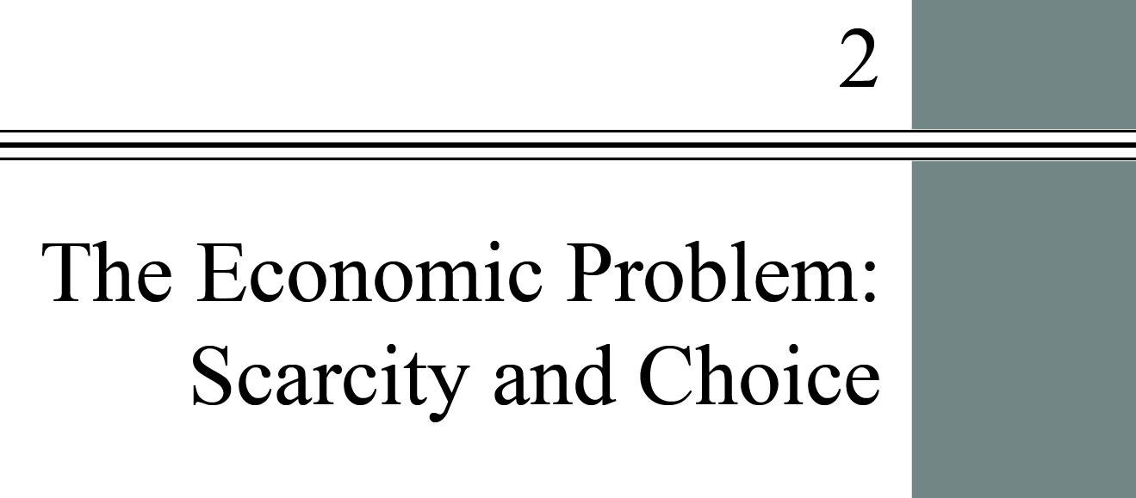

**Chapter Outline**

**Scarcity, Choice, and Opportunity Cost**

Understand why even in a society in which one person is better than a second at all tasks, it is still beneficial for the two to specialize and trade.

**Economic Systems and the Role of Government**

Understand the central difference in the way command economies and market economies decide what is produced.

Detailed Chapter Outline

I. Introduction

This chapter explores the questions of what, how, and for whom to produce. *Human wants are unlimited, but resources are not*. This creates scarcity. Scarcity, in turn, forces us to make choices. The chapter stresses positive and descriptive economics, postponing normative questions until the students have acquired analytical tools.

A. Resources, used in its broadest sense, includes everything from natural resources (timber, minerals, energy), capital (buildings, machines), labor (human capital), and entrepreneurship. Resources are also called *factors of production*, *inputs*, or simply *factors*. *Output* is what is produced, goods and services of value to households.

B. Key definitions:

1. *Capital* includes things that are produced and then used in the production of other goods and services.As used by economists, capital means physical capital, including buildings and machines.

1. *Factors of production* (*factors*) are the inputs into the process of production. Another term for resources.

3. *Production* is the process that transforms scarce resources into useful goods and services.

4. *Inputs* or *resources* include anything provided by nature or previous generations that can be used directly or indirectly to satisfy human wants.

5. Producers are those who transform resources into outputs (final goods and services).

6. *Outputs* are goods and services of value to households.

7. Households are the consumers in the economy. They purchase output.

II. Scarcity, Choice, and Opportunity Cost

A. Scarcity and Choice in a One-Person Economy

1. Bill must make choices about how to allocate resources, what to produce, and how to produce it. Bill’s situation is “constrained choice.” His main constraint is available time. Other constraints are his physical condition, his knowledge and skills, and the resources and climate of the island. Bill must decide what goods and services he wants to produce, what he is able to produce, and how to use the resources to produce what he wants.

2. *Opportunity cost* is the best alternative that we give up, or forgo, when we make a choice or decision. If Bill spends more time hunting he will have less time to build shelter. Similarly, time he spends on the beach also has an opportunity cost.

B. Scarcity and Choice in an Economy of Two or More

1. Now there are two decision makers—Bill and Colleen. Their preferences, skills, and abilities probably differ. They will have to decide how much of each product each person should produce. They will probably benefit from specialization and trade.

2. Specialization, Exchange, and Comparative Advantage:

a. David Ricardo formulated the *theory of* *comparative advantage*, the idea that specialization and free trade will benefit all trading partners, even those that may be “absolutely” more efficient producers. (As we know today, this must be true of any voluntary exchange.) Ricardo’s most important point is that everyone—every individual, firm, and country—has a comparative advantage at something *even if another has an absolute advantage at producing all goods and services*. Trade and specialization allow the most efficient producer to produce each good. This increases productivity and aggregate output.

b. A producer has an *absolute advantage* over another in the production of a good or service if he or she can produce that product using fewer resources (a lower absolute cost per unit). In the text’s example, Colleen has an absolute advantage at both cutting logs and gathering food.

c. *Comparative advantage* is the advantage in the production of a good enjoyed by one country over another when that good can be produced at lower cost (in terms of other goods that must be foregone) than it could be in the other country.

d. Trade means both parties can consume at points outside their individual PPFs. This demonstrates the gains from specialization and trade.

3. Weighing Present and Expected Future Costs and Benefits: There is a trade-off between present and future benefits and costs. The simplest example of trading present for future benefits is saving part of our income, which allows us to consume more in the future. Even Bill, alone on his island, must choose between gathering food for immediate consumption and constructing tools that he can use to produce more in the future.

4. Capital Goods and Consumer Goods: *Consumer goods* are goods produced for present consumption. When a society devotes a portion of its resources to investment in capital, it is trading present benefits for future benefits. *Investment* is new capital additions to a firm’s capital stock. Although capital is measured at a given point in time (a stock), investment is measured over a period of time (a flow). The flow of investment increases the capital stock.

C The Production Possibility Frontier (PPF)

1. The PPF can be used to show the principles of constrained choice and scarcity.

a. A *production possibility frontier* (*ppf*) is a graph that shows all the combinations of goods and services that can be produced if all of society’s resources are used efficiently.

b. All points on the curve are combinations of output produced using full resource employment and production efficiency.

c. *Production efficiency* means producing a given mix of outputs at least cost. This implies producing the maximum quantities of both goods given society’s resources and technology.

d. Points inside the curve are achievable but are not efficient. Points outside the curve are unattainable unless the quantities of resources increase or there is a technological improvement.

e. Different points on the PPF show the quantities of each of the two goods. At point *F* in Figure 2.4 the economy is producing more capital goods and less consumer goods than at point *E*. In subsequent years, the PPF will shift out further from point *F* than *E*.

**Unique *Economics in Practice***

One measure of inefficiency is the unemployment rate, the percentage of the labor force that can’t find work. The unemployment rate fluctuates.

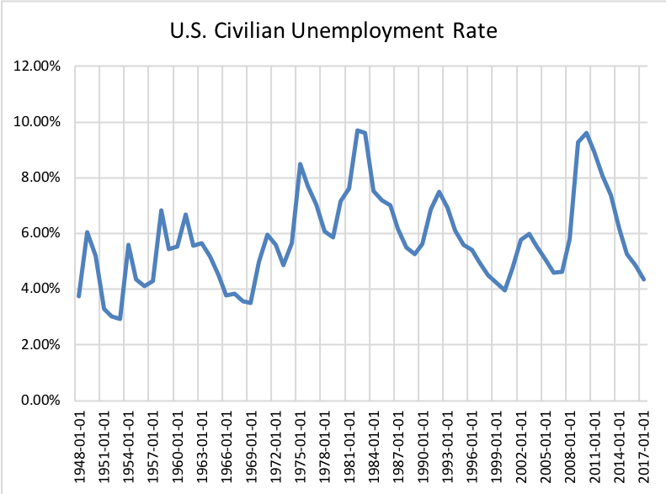

During recessions output falls and the unemployment rate rises. When the economy is expanding, output rises and the unemployment rate fall. This process is usually called a *business cycle*.

Question: The unemployment rate is often called a *countercyclical* variable. Can you figure out why?

Answer: A countercyclical variable moves in the opposite direction from the economy. During an expansion output rises and the unemployment rate falls. During a recession, output falls and the unemployment rate rises. The two variables generally change in opposite directions.

2. Negative Slope and Opportunity Cost

a. When resources are used efficiently the only way to produce more of one good is to produce less of the other. The opportunity cost of increasing production of good *X* by one unit is the number of units of good *Y* that must be sacrificed.

b. The *marginal rate of transformation* (*MRT*) is the slope of the production possibility frontier (ppf).

3. The Law of Increasing Opportunity Cost

a. The “bowed out” shape of the PPF tells us that the more society tries to increase production of one good, the more costly it becomes (in terms of the number of units of the other good that must be given up).

b. In effect, the law of increasing opportunity cost says the absolute value of the slope of the PPF will increase as the quantity on the x-axis increases.

4. The Efficient Mix of Output

a. To be efficient, an economy must produce what people want.

b. All points on the PPF are efficient in production. But the economy must also be at the correct point on the PPF (*output efficiency*).

5. *Economic growth* is an increase in the total output of an economy. Growth occurs when a society acquires new resources or when it learns to produce more using existing resources. Growth causes an outward shift of the PPF. Growth is an increase in the total output of an economy.

6. Sources of Growth and the Dilemma of the Poor Countries

a. Historically, the two most important sources of growth have been the accumulation of capital and technological advance.

b. For poor countries, taking resources out of the production of consumer goods is very difficult because they are living so close to subsistence levels. This lack of saving can make it difficult for them to accumulate capital, pay for research and development, and grow.

c. The paper by Robert Jensen cited in the footnote on p. 34 is an excellent example of how a seemingly minor technological improvement can lead to large welfare gains.

D. The Economic Problem: How do different economic systems answer the three basic questions?

III. Economic Systems and the Role of Government

There are different types of economic systems:

A. *Command Economies* are those in which a central government either directly or indirectly sets output targets, incomes, and prices. There are few true command economies left in the world. Even China has become a “magnet for private capital and entrepreneurship.”

B. Laissez-Faire Economies: The Free Market

1. A *laissez-faire* economy is an economy in which individuals and firms are free to pursue their own self-interest without any government direction or regulation. (“Laissez-faire” is from the French: “allow [them] to do.”) Laissez-faire economies rely on *markets*, institutions through which buyers and sellers interact and engage in exchange. Its characteristics include:

2. *Consumer sovereignty* is the idea that consumers ultimately dictate what will be produced (or not produced) by choosing what to purchase (and what not to purchase). The mix of output produced is dictated by the tastes, preferences, and incomes of consumers.

3. Individual Production Decisions: Free Enterprise:

a. Free enterprise is the freedom of individuals to start and operate businesses in search of profits. This increases output and develops new production techniques.

b. In market systems, prices are signals of relative scarcity. These price signals to consumers and producers guide them in making decisions. This is Adam Smith’s “invisible hand.”

c. Markets promote competition and efficiency.

4. Distribution of Output: Also determined in a decentralized way, the distribution depends on a household’s income and wealth.

5. Price Theory: Prices are the basic coordinating and signaling mechanism. *Wage rates* are the prices of various kinds of labor. From page 38:

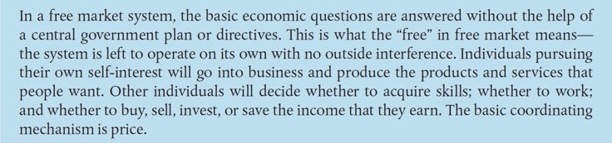

C. Mixed Systems, Markets, and Governments

1. All real-world economies are mixed, with differing degrees of government intervention. Market systems have advantages, but are not perfect.

2. In the United States, governments at all levels accounted for about 20 percent of total output. They directly employ about 14 percent of all workers. Governments redistribute income via taxes and social welfare spending. Finally, they regulate many aspects of economic activity.

3. Remember the “law of unintended consequences.” Government intervention may make things worse instead of better. Government sets and enforces the rules for an economy. Two important rules are the protection of private property and the enforcement of laws governing intellectual property.

****Extended Application

Application 1: The Rising Cost of Services

Consider how the cost of services tends to rise over time. Why do items like haircuts, medical care, and education keep getting more and more expensive, both absolutely (they cost more dollars) and relatively (they require a larger and larger portion of our incomes)? Using the concept of opportunity cost, the production possibilities frontier, and a little common sense, we can come up with a realistic answer.

The three items mentioned above are examples of services. A service is, by definition, provided by workers directly to consumers. (One of the fastest-growing service sectors in the United States is meals eaten away from home.) A service is always consumed the moment it is produced. It cannot be brought home in a shopping bag or resold to someone else. Services can’t be inventoried. To keep the analysis simple, let us assume that a nation can produce only one good (T-shirts) and one service (haircuts). The nation’s production possibilities frontier is shown in the following graph:



Initially, at Point *A*, the economy is producing 100 haircuts and 300 T-shirts per day. Between points *A* and *B* the opportunity of producing 50 more T-shirts (increasing from 300 to 350) requires the sacrifice of 25 haircuts (decreasing from 100 to 75). The marginal rate of transformation is thus 50/25 = 2.00. Now (as students who are taking microeconomics will see later on) relative prices in a market economy usually correspond quite closely to opportunity costs. That is, if producing 50 more T-shirts uses resources that could otherwise produce 25 haircuts, then a haircut should cost about two times the cost of a T-shirt. Let us suppose that for this economy at Point *A*, each T-shirt costs $5 and each haircut costs $10.

Many economists believe that the growth of productivity (output per hour) is much slower for services than for goods. This is easy to see in the case of T-shirts versus haircuts. Over the past 50 years, the number of T-shirts a worker can produce in an hour has increased dramatically due to technological advances in cotton-picking, weaving, and assembly-line production techniques. Over the same period, however, the number of haircuts a barber could perform in an hour has probably increased very little, if at all.

The effect of this asymmetrical change in productivity is illustrated in the diagram. Note that the vertical (T-shirt) intercept of the production possibilities frontier has increased, reflecting an increase in the maximum quantity of T-shirts that could be produced—after the productivity change—if all resources were devoted to T-shirt production. But the horizontal (haircut) intercept remains the same, as there has been no productivity change in this industry.

Suppose that the economy ends up at Point *C* on the new PPF. The economy is producing more T-shirts (160) and more haircuts (400). In addition, the opportunity cost has increased. As the economy moves from Point *C* to Point *D* (after the productivity change) it could produce 100 additional T-shirts with a sacrifice of 25 haircuts. The opportunity cost is now 4.00 instead of 2.00. In other words, even though there has been no change in haircut technology or productivity, the opportunity cost of haircuts has risen! One haircut should now cost the same as 10 T-shirts. If T-shirts continue to cost $5 each, then haircuts should rise in price to $50. Alternatively, if T-shirts fall to $1.50 each, haircuts should remain priced at $15. Either way, the relative price of haircuts will rise, as the opportunity cost of haircuts has risen.

This simple analysis has far-reaching implications. It explains why college tuition rises faster than the general price level, as providing an education relies heavily on services (teaching, building maintenance, administrative services) rather than goods. Similarly, it suggests that ongoing efforts to reform health care may be only partially successful. We can certainly choose, as a nation, to provide better health care to more of our population. But if manufacturing productivity continues to increase faster than productivity in medical services, then the relative price of health care like the relative price of haircuts, will rise.